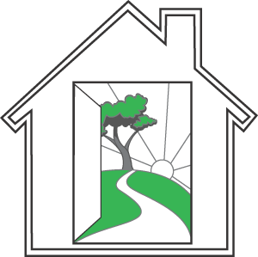
Mental Health Association of San Mateo County
2686 Spring St., Redwood City, CA 94063

APPLICATION TO HAVE A COMMUNITY FRIEND

The Community Friend program is a social-recreational program designed to enhance your quality of life by matching you with a peer who will help you go out in the community to participate in activities of mutual interest. The goal is that you will be able to get out in the community on your own or with new friends and utilize the skills and expertise you have learned.

Print Name:

Address:

City/Zip: Phone: Date

Treatment Team:______________________________________________________________________

Return this form by mail to MHA, 2686 Spring St., Redwood City, CA 94063,
Att: Georgia Peterson or by faxing to (510) 879-0354. For further information call (650) 298-9846

Please check activities below that best suit you and are comfortable for you to do with a peer.

Visiting museums Attending sporting events

Bingo Golf

Art & Craft Fairs Computers

Shopping Listening to music

Bowling Swimming

Dining out Reading

Exercise/Physical fitness Doing crafts

Going to the movies Getting a manicure/pedicure

Going to the park or beach Chess

Dancing Gardening

Plays/Theater Pool/Billiards

Cooking Trips to San Francisco or San Jose

Other

